Physics 11

Vectors and Linear Motion Test

|  |  |
| --- | --- |
| Student Name |  |
| Teacher |  |

**Time allowed for this paper**

Working time for paper: 60 minutes

**To be provided by the supervisor:**

This Question/answer booklet;

Formulae and constants sheet

**To be provided by the candidate**

Standard items: Pens, pencils, eraser or correction fluid, ruler, highlighter

Special items: Drawing instruments or templates.

A **scientific** (i.e. non graphics) calculator satisfying curriculum council requirements.

**Structure of this paper**

|  |  |  |  |  |  |
| --- | --- | --- | --- | --- | --- |
| Section | Number of questions available | Suggested working time  (minutes) | Your Mark | Marks available | Percentage of test |
| Section One:  Short answer | 6 | 17 |  | 14 | 28 |
| Section Two:  Extended answer | 5 | 32 |  | 27 | 54 |
| Section Three:  Comprehension  and data analysis | 1 | 11 |  | 9 | 18 |
|  |  | **Total** |  | 50 | 100 |

**Instructions to candidates**

1. To achieve full marks, clear, logical working and diagrams MUST be shown.
2. When calculating numerical answers, show your working or reasoning clearly. Give final answers to **three** significant figures and include appropriate units where applicable. Estimates should be to two significant figures.

**Section One: Short answers (14 marks)**

**Question 1**

Examine the motion graph below and accurately describe the motion in each time interval.

(no values are required)

|  |  |
| --- | --- |
| **0-2** seconds |  |
| **2-4** seconds |  |
| **4- 6** seconds |  |

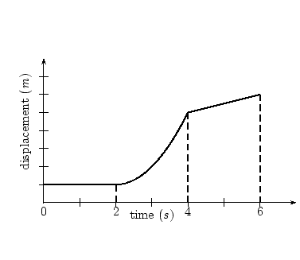

(2 marks)

**Question 2**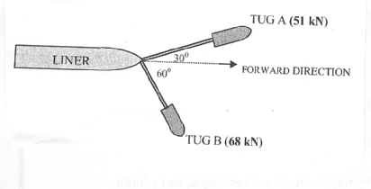

Two tugs are pulling a large ocean liner out to sea on ropes. Tug A exerts a force of 51 kN at an angle of 30o to the forward direction and tug B exerts a force of 68 kN at an angle of 60o.

Determine the magnitude of the resultant force on the liner.

**(2 marks)**

**Question 3**

You are the driver of a car involved in a head-on crash. After the crash you are very thankful for the fact that your car crumples and is fitted with working air bags. Explain how crumple zones and air bags reduce the force on the occupants of a car in a car crash.

|  |
| --- |
|  |
|  |
|  |
|  |
|  |
|  |

**(2 marks)**

**Question 4**

Draw a free body diagram of a body on a frictionless incline, which is at 25o to the horizontal and determine the value of the acceleration down the plane?

**(3 marks)**

**Question 5**

If a 5.40 g bullet is fired horizontally into a suspended 10.0 kg block of wood and causes the block, with bullet embedded, to move off with a horizontal velocity of 0.300 ms-1. What was the impact velocity of the bullet? (Assume no energy lost.)

**(3 marks)**

**Question 6**

Victoria works in Coles doing night fill. She has to lift three (3) 1.50 kg boxes of laundry detergent from the floor to the shelf 1.10 m above the floor. If it took 1.50 seconds to lift all boxes at once to the shelf, what power was required?

**(2 marks)**

**Section Two: Extended answers (27 marks)**

**Question 7**

Whilst travelling at 60 kmh-1, Victoria sees a traffic light turn orange when she is 45.0 m from the light. She has a reaction time of 1.2 s before she applies the brakes. At what rate must she decelerate so as to stop at the traffic light?

(4 marks )

**Question 8**

The following questions relate to the delivery driver below, who is loading a barrel into the back of a truck using a ramp angled at 15° to the horizontal. He has stopped at the top of the 5.30 m long ramp, when he loses grip and the barrel starts to roll back down the slope.

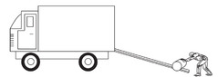

1. Using an appropriate vector diagram, determine the acceleration on the barrel as it rolls down the slope.

(2 marks)

1. Determine the speed of the barrel as reaches the bottom of the ramp.

(2 marks)

1. Determine how long the barrel takes to reach the bottom of the ramp.

(2 marks)

**Question 9**

A vertical cylinder contains a spring which is used to launch a pool ball into the air. The spring is compressed 30 cm downwards from the top of the 50 cm long tube and then let go. The ball leaves the tube with a velocity of 20ms-1.

1. What acceleration does the spring provide to the ball between the compressed point and the ball leaving the cylinder?

(2 marks)

1. How high above the ground will the ball reach?

(2 marks)

1. How long after leaving the tube will the ball remain in the air before hitting the ground?

(2 marks)

**Question 10**

Golf ball being struck by the club; photograph taken with an exposure of 10−6 …
[Credits : Harold Edgerton, Massachusetts Institute of Technology]A golfer played a beautiful shot at a weekday golf competition. His golf ball, with a mass of 45.9 grams, was hit with a 0.500 kilogram club travelling at 30.0 ms-1. The ball was given a velocity of 125 ms-1.

1. What is the velocity of the club after the collision?

**(3 marks)**

1. If the collision took place over 2.20 x 10-3 s, what is the average force that was exerted on the ball over this time?

**(2 marks)**

**Question 11**

Consider an 80.0 kg carriage on a roller coaster ride as shown in the diagram below:



If the initial velocity of the carriage along AB is 12.0 ms-1, calculate the following:

1. The carriage’s mechanical energy at AB?

**(2 marks)**

1. The velocity of the carriage at point C?

**(2 marks)**

1. The velocity of the carriage along DE?

**(2 marks)**

**Section Three: Comprehension and Interpretation (9 marks)**

**Question 12 Graphing Motion**

A remote controlled drone is being used to take photos of a property when the controls malfunction and it begins to randomly move about. Its motion is shown in the graph below.

Use this graph to answer the questions which follow.

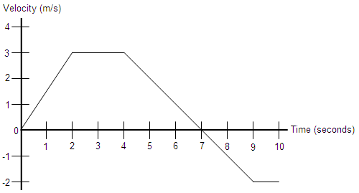

1. What is the object's acceleration at the following times: t = 1, t = 3, and t = 6 seconds?

(3 Marks)

1. Sketch the corresponding acceleration vs. time graph from t = 0 to t = 10 seconds in the space below. Include important values on your axes.

(3 Marks)

1. Determine the final displacement of the object at the end of its journey. Show all calculations.

(3 Marks)

Section C 5 Extended Answer Questions – 30 marks

